RESOLUTION NO.__________

RE: CERTIFICATE OF APPROPRIATENESS UNDER THE
PROVISIONS OF THE ACT OF THE PENNSYLVANIA
LEGISLATURE 1961, JUNE 13, P.L. 282 (53
SECTION 8004) AND BETHLEHEM ORDINANCE NO.
3952 AS AMENDED.

WHEREAS, it is proposed to remove the old sign and replace with a vinyl cling window sign at 12 W. Fourth St.

NOW, THEREFORE, BE IT RESOLVED by the Council of the City of Bethlehem that a Certificate of Appropriateness is hereby granted for the work.

Sponsored by: (s)

(s)

ADOPTED BY COUNCIL THIS DAY OF

(s)
President of Council

ATTEST:

(s)
City Clerk

HISTORIC CONSERVATION COMMISSION

CASE # 579– It is proposed to remove the old sign and replace with a vinyl cling window sign at 12 W. Fourth St
OWNER/APPLICANT: Linda Villani / Alison Pokrivchak

The Commission upon motion by Mr. Lousch seconded by Mr. Silvoy adopted the proposal that City Council issue a Certificate of Appropriateness for the proposed work described herein:
- The proposal remove the old sign and replace with a vinyl cling window sign at 12 W. Fourth St was represented by Alison Pokrivchak.
- The sign will read “Hair by Eskandalo! Est. 2007” with scissors and clippers below. The sign is approximately the same size as the old one and will be centered on the window.
- The proposed motion was unanimously approved.

CU: cu
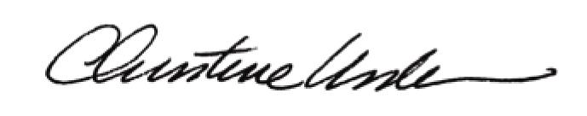

By:

Date of Meeting: January 25, 2016 Title: Historic Officer

